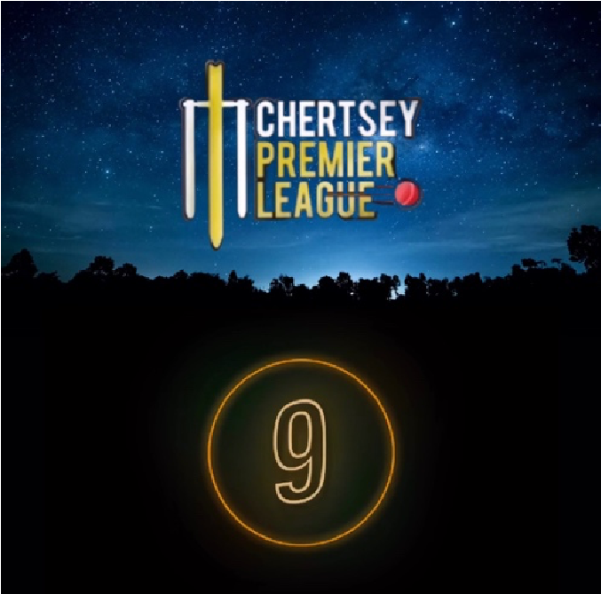

CPL 10 RULES 2026

FORMAT

Rules

- Power Play – powerplay first 6 overs (2 out)
- A time penalty of 1 fielder in if a team goes over 1hr 15m for their innings will be enforced by the umpires. This does not apply in the Final.

1.2 Points o 4 points for a win
- 1 bonus point for one of either 150 runs scored OR 6 wickets, NOT a point for each *
- rained off mean each receives 2 points each
- Super over for tied games
- In case of a tie-on points after round 3 net run rate decides who progresses
- If the final is a tie the title is decided by a super over

1.3 Other o New batsman comes in on strike

DRAFT
To be held on the night of 2nd May 2026 – Lloydy can compere
Auction Sponsors to be in attendance
Hats

CPL Auction Rules o All teams to receive £40m each to Auction squad limit 15 players

Players entering the Bidding Draft must have played 1 senior league game (including colts players over the age of 15) and will be vetted by the CPL Committee.

- Players not bought at auction will be allocated to a squad post-auction

Squad Qualifiers to No retainee per team to 2 Luxuries per team 2 Legends per team (CCC player but didn’t play last season) o Luxuries can move team but by agreement from the other captains only

Ed into auction

- All teams must have one U17 player in their teams – failure to do will incur their opportunity to secure bonus points in case of a loss.

AWARDS
The winner of either the orange or purple cap shall be decided on the highest total amount of runs or wickets they score for their contracted team (auction and draft players), or the highest amount for one team (luxuries and legends) – any runs scored or wickets accumulated for the second team will not count – if they have played four games for two teams for example, it is their contracted team’s runs and wickets (auction and draft players) or highest amount for any one team (luxuries and legends) that is taken.

Budget:

2-year sponsorship
DJ Ross for each round
Party
Sponsor for CPL
Finals Day.
Umpires
Crowd Catch
Discuss Sponser

